A comparison of various classification methods for predicting hospital readmission of patients
Machine Learning and Pattern Recognition - Project 1

Shanu Kumar
School of Computer Science
University of Windsor
Windsor, Canada
kumar34@uwindsor.ca
Azin Masoudi
Dep. Of Electrical Engineering
University of Windsor
Windsor, Canada
masoudia@uwindsor.ca
Mahshad Hashemi
School of Computer Science
University of Windsor
Windsor, Canada
hashem91@uwindsor.ca

Abstract—Treatment of hyperglycemia in hospitalized patients has a significant bearing on their outcome especially when diabetes burden among hospitalized patients is on the rise, and readmissions cause a substantial portion of this burden. This project works on readmission prediction based on a crucial factor called HbA1c, which is related to hyperglycemia. A big dataset collected from 130-us hospitals in a period of time has been used and analyzed based on machine learning algorithms for classification. The prediction findings aids hospital systems in their efforts to improve inpatient care by considering HbA1c test in their patients’ symptoms analyzing.
Keywords— Classification, Random Forest, Neural Networks, SVM, Machine learning

Introduction
Hospital readmission is considered to be a reliable indicator of the quality of care provided by hospital [1]. A hospital’s emergency readmission rate is often used when assessing the quality of its care because a significant proportion of those readmission should be prevented if prior care was adequate [2]. Researchers at the Agency for Healthcare Research and Quality (AHRQ) discovered that approximately 3.3 million patients were readmitted within 30 days of being discharged in the United States in the year 2011. It is estimated as of 2015, 30.3 million Americans of all ages had diabetes, of which 7.2 million are unaware [3], [4]. The American Diabetes Association reported spending $250 million on the treatment of readmitted diabetic patients [5]. There are 9.3% of Americans with diabetes, of which 28% are undiagnosed. Because of this high prevalence, diabetes is a frequent comorbid condition among hospitalized patients [6]. This background indicates that Diabetes is a substantial, growing, and costly burden among hospitalized patients, and readmissions make up a significant portion of this burden. It is possible to reduce health care costs while improving patients care by reducing the readmission rates of people with diabetes. There are few studies that have investigated the impact of increasing diabetes treatment on readmission rates, some of which are going to be discussed in the next section.

Related Works
In [3], the authors propose a new model based on unsupervised method. Their model can identify whether a hospitalized diabetic patient will be readmitted within 30 days or not with an accuracy of 95.2% and Area Under the Receiver Operating Characteristics (AUROC) of 97.4% on data collected from 130 US hospitals between 1999-2008.
Another study uses diabetes mellitus (DM), defined as any International Classification of Diseases discharge diagnosis. they analyzed two separate sets of patient data. The first was a review of all patients with a principal admission diagnosis of diabetes admitted to any adult service within the University of Michigan Health System (UMHS) in a specific period. The second review incorporated all grown-ups released from UMHS between in a period with release determination of DM. results showed that 24.3% of readmission rates were in patients with DM contrasted with 17.7% in those without DM [6].
To create a model for predicting 30-day readmission to the hospital, a study used data of 1-lac diabetes patients with 50 features and processed that with algorithms such as Logistic Regression, Decision Tree, Random Forest, Adaboost and XGBoost and highest accuracy for prediction achieved using Random Forest [2].
There are many factors impact readmission rate such as HbA1c as a term refers to glycated hemoglobin, a protein within red blood cells that carries oxygen throughout the body, that joins with glucose in the blood to become glycated. A high HbA1c is associated with an increased risk of diabetes complications, therefore it plays a crucial role for diabetics. Research regarding this term analyzed 70000 clinical database patient records. The link between HbA1c test and early readmission modelled using multivariable logistic regression. They even took demographics, severity and type of the disease, and type of admission into consideration. The statistical model and their findings showed that paying more attention to diabetes as measured by HbA1c could improve patient outcomes and minimize inpatient care costs [7].

Dataset and Methods
In this project we are using “Diabetes 130-US hospitals for years 1999-2008” from UCI website [8]. This information was compiled to look at factors that influence readmission as well as other diabetes-related outcomes. Dataset characteristics have been briefly illustrated in table below.
Table 1: Dataset Information
Data Set Characteristics | Multivariate
Attribute Characteristics | Integer
Associated Tasks | Classification
Number of Instances | 100000
Number of Attributes | 55
Missing Values | Yes
Date Donated | 2014-05-03
Number of Web Hits | 368607

Dataset information specification
The data represents clinical treatment at 130 US hospitals and integrated delivery networks during a ten-year period (1999-2008). It has more than 50 features that indicate patient and hospital outcomes. Information was extracted from the database for encounters that satisfied the following criteria:
- It is a hospital admission.
- It is a diabetic encounter, that is, one during which any kind of diabetes was entered to the system as a diagnosis.
- The length of stay was at least 1 day and at most 14 days.
- Laboratory tests were performed during the encounter.
- Medications were administered during the encounter.
The data contains such attributes as patient number, race, gender, age, admission type, time in hospital, medical specialty of admitting physician, number of lab test performed, HbA1c test result, diagnosis, number of medication, diabetic medications, number of outpatient, inpatient, and emergency visits in the year before the hospitalization, etc.
A paper released its results according to this dataset to measure HbA1c and its impact on hospital readmission rates [6], which has already been discussed in previous section.

Methods
In this project, different classification methods were used and their hyperparameters were adjusted in order to have a comprehensive viewpoint over the problem. Most machine learning and deep learning algorithms feature a set of parameters called hyperparameters that can be adjusted. Before we train the models, we need to set hyperparameters. In order to develop robust and accurate models, hyperparameters are essential. They assist us in finding the right balance of bias and variance, preventing the model from overfitting or underfitting. To adjust the hyperparameters, we must first comprehend what they mean and how they affect the model. Trying a bunch of hyperparameter settings at random would be a tiresome and never-ending task. First, the utilized methods and their important hyperparameters will be introduced generally.

Decision Tree
Decision trees (DTs) are supervised machine learning methods for classifying examples consisting of Nodes, Branches, Leaves. On each Node there is a specific value for each attribute. Branches are a connection to next node or leaf based on the answer of each node. And finally, leaf as the terminal node, clarifies the class of each example [9].
There are three important hyperparameters that affect the size and complexity of our tree: The min_samples_split parameter defines the minimum number of data points that are needed in order for the algorithm to attempt a split before it is forced to create a leaf node. The default value is 20. The max_features represent the number of features to consider when looking for the best split. The max_depth parameter limits the maximum number of nodes between a leaf node and the root node. The default value of 30 is quite liberal here, allowing for fairly large trees to be built.

Random Forest
Random forest method merges multiple decision trees to achieve a more accurate and stable prediction. A random sample of the original data is used to build each tree. Furthermore, at each tree node, a subset of features is randomly selected in order to find the optimal split. It can be used to solve problems involving classification and regression. Here, we use this method as classification [10].
Random forest has several hyperparameters that can be tuned. The n_estimators hyperparameter simply specifies the number of trees the algorithm constructs before doing maximum voting or averaging predictions. A bigger number of trees improves performance and makes predictions more stable, but it also slows down processing. Another crucial hyperparameter is max features, which specifies the maximum number of features that a random forest evaluates when splitting a node. The minimal number of leafs necessary to separate an internal node is determined by min_sample_leaf. The n_jobs hyperparameter specifies how many processors the engine is permitted to employ. It can only use one processor if it has a value of one. There is no limit if the value is “-1”. Finally, there's the random forest cross-validation method oob score (also known as oob sampling). About one-third of the data in this sampling is not used to train the model but can be used to assess its performance. It's comparable to the leave-one-out cross-validation method, except it comes with nearly no additional computational overhead.

Logistic Regression
In logistic regression, the probability of a discrete outcome is modeled based on a number of input variables .For binary and linear classification problems, logistic regression is the more efficient method [11]. Typical logistic regression models have a binary outcome; something that has two possible values such as true/false or yes/no. multinomial logistic regression can model scenarios with more than two discrete outcomes. Logistic regression can be used to analyze classification problems, when trying to determine if a new sample fits the category most effectively. With linearly separable classes, this method achieves very good results [12].
Logistic regression does not really have any critical hyperparameters to tune. Sometimes, you can see useful differences in performance or convergence with different solvers such as, Regularization (penalty) and C which controls the penalty strength.

Nueral Network

It has been found that Neural Network (NN) models can replace statistical and optimization models in geography in the 1990s and are often used for predicting and forecasting telecommunications, trade, and transportation flows [15]. Complex nonlinear functions can be satisfactorily addressed by NN and therefore, it can use high-dimensional datasets for medical anomalies detection through physiological measurements [16]. As a result, it facilitates the recognition and classification of patterns of behavior and numerous problems of classification, prediction, control, and function fitting have been solved using them [17].
Two hyperparameters that can be tuned are learning rate and the number of units in our model.

results and implementation settings
Now that the methods have been thoroughly explained, it is time to see how they perform in our problem. But before implementing any algorithms, the first step in this project is to preprocess and analyze the dataset in stages.
- The age ranges are like [0–10], [10–20], and [20–30]. Because the age feature is ordinal rather than categorical, we should convert it to numbers and consider it as a numeric feature. We're switching the age field to a numeric field, by using their average value instead.
- Only very few of the columns have missing values. These are, ‘race', 'weight', 'payer_code', 'medical_specialty', 'diag_1', 'diag_2', 'diag_3'. As you can see in the table 2, about 40% of ‘weight’, 97% 'payer_code' and 49% of 'medical_specialty' are missing values and affect the predictions, so we have to drop them.

Table 2- Non-Values
Features | Non-Values
race | 2.233555
weight | 96.858479
payer_code | 39.557416
medical_specialty | 49.082208
Diag_1 | 0.020636
Diag_2 | 0.351787
Diag_3 | 1.398306

- There are three targets in the dataset: to be readmitted after 30 days, to be readmitted before 30 days and not to be readmitted. The target value distribution is depicted in the figure below.

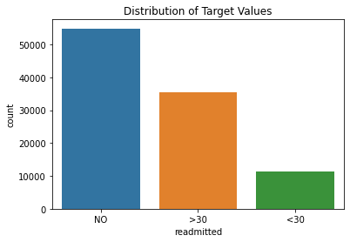
As can be seen, the readmission after 30 days covers approximately 10% of the target values. As a result, we omitted the third class for the sake of simplicity and improved results. In the new configuration, we only have two classes: 0 (not readmitted) and 1(readmitted). The third class (readmitted after 30 days) is counted as 0 (not readmitted). Following that, the distribution of target values changes as follows:

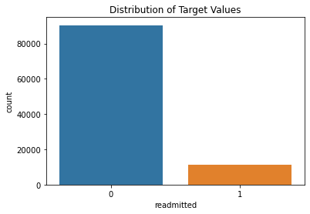
- In this dataset there are five different races. Caucasian, African American, Hispanic, Asian, Other. The distribution of them is like this:

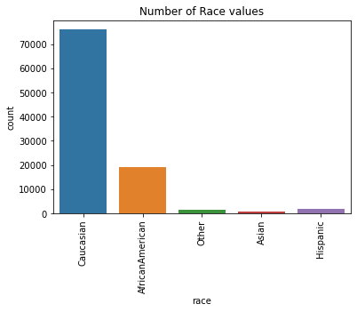

Table 3- Proportion of Races
Race | Proportion of races
Caucasian | 76.486788
African American | 19.307891
Hispanic | 2.047380
Other | 1.513674
Asian | 0.644266

Table 3 shows that Caucasians make up 76 percent of all our data. The remaining 24% is made up of African Americans, Hispanics, Asians, and Others. To achieve a more even distribution, we decided to exclude Asians and Hispanics and reclassify them as Others. The proportion after mapping is as follows:

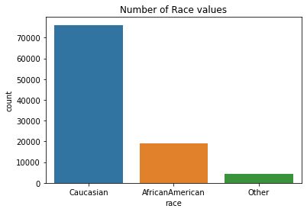

Table 4- Proportion of Races After Mapping
Race | Proportion of races
Caucasian | 76.486788
African American | 19.307891
Other | 4.205321

Based on these new values, we can conduct a more in-depth analysis of patient readmission.
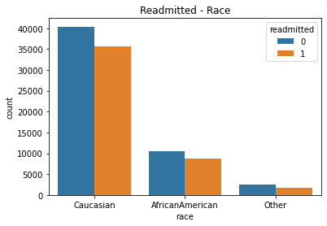
This graph shows that most readmitted patients are Caucasian or African American. Although the Other values are lower than Caucasian, the graph below shows that their Readmitted Probability is relatively like Caucasian.
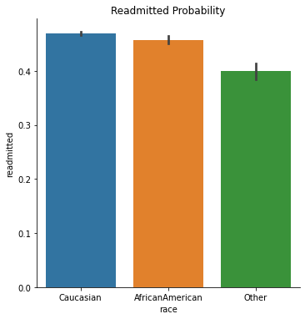
- There is an integer identifier with 29 distinct values. For instance, discharged to home, expired, not available and etc.. The following graph depicts the number of occurrences for these 29 discharged disposition IDs:
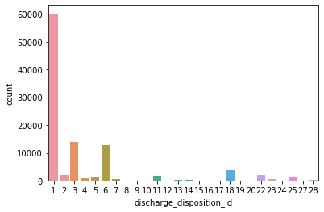

When we look at the graph, we can see that there are far too many values. To get rid of that situation, we followed these rules:
If it includes the word "home," we will consider them as one category. Otherwise, it will be as Other. The probability of readmission for this new configuration is like this:

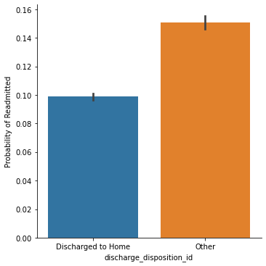

- Another feature is time in hospital, which is an integer number that represents the number of days between admission and discharge. Shortly it is "treatment time". The duration of treatments is depicted in the graph below.

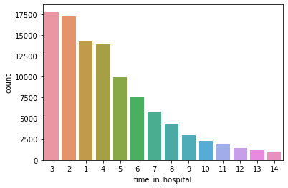

The graph below perfectly illustrates how treatment time is related to the likelihood of being readmitted.

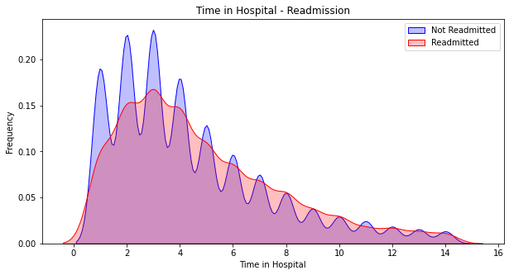

These are some significant steps of preprocessing and analysis of data that we took but not all of them (The rest is available in the code). Now, its time to see the results for the classification algorithms that we implemented. As mentioned before, there are several parameters for each algorithm that can be adjusted to have different results.

- Decision Tree

Setting | Hyperparameters |  |  | Metrics
Setting | Min  samples  split | Max  features | Max  Depth | Accuracy | F1-Score | Precision | Recall
1 | default | default | 100 | 0.80 | 0.81 | 0.81 | 0.81
2 | default | default | 50 | 0.80 | 0.81 | 0.81 | 0.81
3 | default | default | 10 | 0.80 | 0.72 | 0.72 | 0.72

Decision tree with default parameters is giving better results. Increasing depth does not affect the result however decreasing the depth for tree reduces the precision, recall and F1- score which is not a desired results because the data is imbalanced, and these parameters give us better understanding of model performance.

- Random Forest

Setting | Hyperparameters |  |  |  | Metrics
Setting | N estimators | N  jobs | Max  features | Min  Sample  leaf | Accuracy | F1-Score | Precision | Recall
1 | 50 | None | auto | 1 | 0.88 | 0.88 | 0.90 | 0.87
2 | 100 | None | auto | 1 | 0.88 | 88 | 0.90 | 0.87
3 | 500 | None | auto | 1 | 0.88 | 0.89 | 0.89 | 0.89

Random forest overall is giving good results with imbalanced dataset. After up-sampling of data accuracy, precision, recall all parameters are above 85% which is better compared to other models. Model with 500 estimators is giving good result. The performance can be improved with improved feature engineering.

- Logistic Regression

Setting | Hyperparameters |  | Metrics
Setting | penalty | C | Accuracy | F1-Score | Precision | Recall
1 | L1 | default | 0.72 | 0.73 | 0.72 | 0.75
2 | L2 | default | 0.73 | 0.74 | 0.72 | 0.76

Model with L2 regression is giving slightly better result than L1 penalty.

- Neural Networks

Setting | Hyperparameters |  | Metrics
Setting | Learning  Rate | Num  Units | Accuracy | F1-Score | Precision | Recall
1 | 0.0001 |  | 0.80 | 0.82 | 0.80 | 0.81
2 | 0.01 |  | 0.76 | 0.76 | 0.75 | 0.74
3 | 0.001 |  | 0.78 | 0.78 | 0.76 | 0.78

Neural network with low learning rate is performing better. Since the data is non-scaled it is giving less accuracy compared to random forest which is good model in such scenario.

Comparison of the 4 methods
- Table Type Styles
Methods | Metrics
Methods | Accuracy | F1-Score | Precision | Recall
Decision Tree | .80 | 0.81 | 0.81 | 0.81
Random Forest | 0.88 | 0.89 | 0.89 | 0.89
Neural Networks | 0.80 | 0.82 | 0.80 | 0.81
Logestic Regression | 0.73 | 0.74 | 0.72 | 0.76

Random forest being one of the state-of-the-art models is giving best result compared to all other models after doing the up sampling of data. Since the data was not scaled on the dataset random forest outperformed neural network and many of the datapoints had nan value which was changed to some other numerical value however it has affected the end results. Results with scaled data for neural network is expected to improve and if missing data is handled in any better way. So this would be one open area which can be taken into consideration in future work.

conclusion
This project analyzed the readmission patterns of diabetic patients, using five machine learning methods: Decision Tree, Random Forest, Logistic Regression and NN. Machine learning classification methods help in providing more than 88% accurate predictions.

future works
Analysis of embedding matrices can aid in interpreting and visualizing the distinct features. Also, studying of dimensions of each embedding can be added to the research. Furthermore, automated extraction of standard features from complex medical records suggested by [18], can result in more precise prediction.

References

- A. Hammoudeh, G. Al-Naymat, I. Ghannam, and N. Obied, “Predicting Hospital Readmission among Diabetics using Deep Learning,” Procedia Computer Science, Volume 141, pp. 484-489, 2018.
- A. Sharma, P. Agrawal, S. Goyal, V. Madaan, “Prediction on diabetes patient's hospital readmission rates,” ACM Internatio nal Conferenc e Proceeding series, pp. 1-5, June 2019.
- Sarthak, S. Shukla, and S. Prakash Tripathi, “EmbPred30: Assessing 30-days Readmission for Diabetic Patients using Categorical Embeddings,” 2020
- hcup-us.ahrq.gov, “Conditions With the Largest Number of Adult Hospital Readmissions by Payer, 2011,” Available: https://www.hcup-us.ahrq.gov/reports/statbriefs/sb172-Conditions-Readmissions-Payer.jsp, [Accessed Apr- 2014].
- M. Damian, “Predicting Diabetic Readmission Rates: Moving Beyond Hba1c. Curr Trends Biomedical Eng & Biosci,” 2017.
- Ostling, S., Wyckoff, J., Ciarkowski, S.L. et al. “The relationship between diabetes mellitus and 30-day readmission rates,” Clin Diabetes Endocrinol 3, 2017.
- B. Strack, J. P. DeShazo, C. Gennings, J. L. Olmo, S. Ventura, K. J. Cios, and J. N. Clore, “Impact of HbA1c Measurement on Hospital Readmission Rates: Analysis of 70,000 Clinical Database Patient Records.” BioMed Research International, 2014
- archive.ics.uci.edu, “Diabetes 130-US hospitals for years 1999-2008 Data Set,” Available: https://archive.ics.uci.edu/ml/datasets/Diabetes+130-US+hospitals+for+years+1999-2008, [Accessed 2014 ].
- J. C. Tong, S. Ranganathan,. Computational T cell vaccine design,. In Woodhead Publishing Series in Biomedicine, Woodhead, 2013, pp. 59-86.
- S. Misra, H. Li,. Noninvasive fracture characterization based on the classification of sonic wave travel times. Gulf Professional, 2020, pp. 243-287.
- Thomas W. Edgar, David O. Manz,. Research Methods for Cyber Security, Exploratory Study. Syngress, 2017, pp. 95-130.
- A. Subasi,. Practical Machine Learning for Data Analysis Using Python, Machine learning techniques,. Academic Press, 2020, pp. 91-202.
- R. Gholami, N. Fakhari,. Handbook of Neural Computation, Support Vector Machine: Principles, Parameters, and Applications,. Academic Press, 2017, pp. 515-535.
- J. Dukart,. Brain Mapping, Basic Concepts of Image Classification Algorithms Applied to Study Neurodegenerative Diseases,. Academic Press, 2015, pp. 614-646.
- I. Casas. Neural Networks,. International Encyclopedia of Human Geography, Elsevier, 2009, pp. 419-422.
- F.H. Guenther. Neural Networks: Biological Models and Applications. International Encyclopedia of the Social & Behavioral Sciences, Pergamon, 2001, pp. 10534-10537.
- Luigi dell’Olio, Angel Ibeas, Juan de Oña, Rocio de Oña. Data Mining Approaches. Public Transportation Quality of Service,Elsevier, 2018, pp. 155-179.
- T. Tran, W. Luo, D. Phung, et al. “A framework for feature extraction from hospital medical data with applications in risk prediction,” BMC Bioinformatics, 201

